Trigonometric Fourier Series

A signal f(t) is periodic if f(t) = f(t + T0), for all t.

The smallest value of T0 satisfying the periodicity condition is the period of the f(t).

A periodic signal must be an everlasting signal (starting at t = - $∞$)

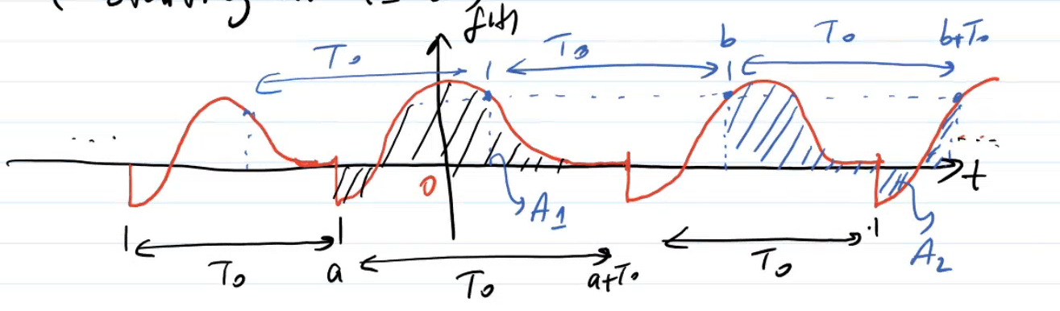

f(t) can be generated by periodic extension of any segment of f(t) of duration T0.

The area under f(t) over any interval of duration T0 is the same

Fourier Series is applied to periodic signal.

A sinusoid,

Let us consider,

f(t) is periodic signal.

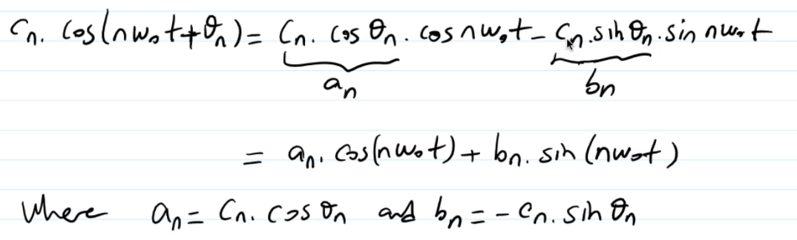 in terms of sines and cosines.

Unknown coefficients are red ones. We try to find them.

Computing the coefficients of a Fourier Series:

Integrations are over one period.

The Fourier Spectrum – Visualization of your result – How we visualize fourier series into figures:

Fourier spectrum consists of 2 figures – fig 1 and fig 2. Combination of these 2 is called fourier spectrum.

Cn 🡪 amplitude (y-axis)

w 🡪 frequency

🡪 phase

Example:

We start from regular trigonometric fourier series then move to the compact trigonometric fourier series.

For and bn, n is from 1 to infinity.

We need compact trigonometric fourier series.

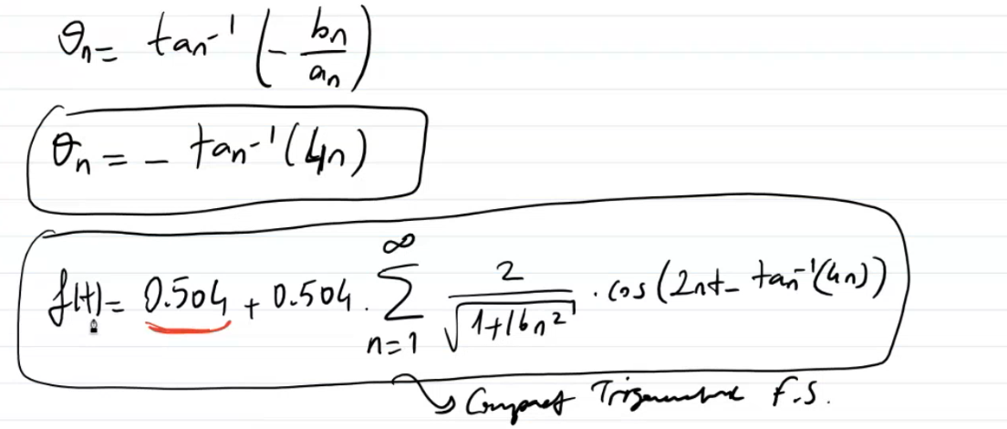

For n = 1, w = 2. 🡪 w0 = 2 $π$/T0 = 2 $π$/ $π$ = 2 🡪 n.w0 = 2n = nth harmonic

For n = 2, w = 4; for n = 3, w = 6, …

starts from n = 0. As we increase w, it starts to approximate to -/2 = -90o

We can write down in terms of equation (blue smiling face equation):

Exponential Fourier Series

Sinusoid in terms ıf compact trigonometric

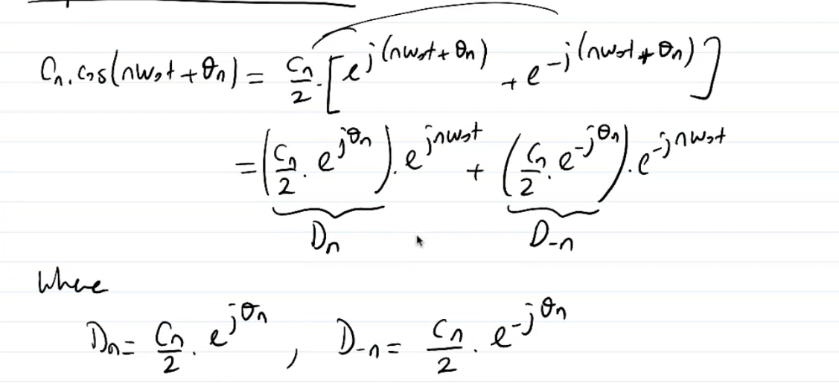



cos can be written down in terms of exponential.

Dn and D-n are symmetric. So we combined them.

Example:

?

n =

We have to find Dn and w0.

Spectrum:



Red line 🡪 Convert to polar form.

< kinda sign is phase information.



See that |Dn| is symettric for – and + values.

It is converging to = 900 when it goes to - $∞$, it is converging to - = -900 when it goes to $∞$.

See symmetry in both amplitude and phase spectrum.